PHYS1110D – Engineering Physics: Mechanics and Thermodynamics

Tutorial Problems for Week 4: Newton’s Laws; Work and Energy; Vectors and Matrices

**Problem 1 – Average Value**

In the lecture, you learned that the average velocity with respect to time over $\left[t_{a}, t_{b}\right]$ is given by

$$\overline{v}=\frac{Δx}{Δt}=\frac{x_{b}-x_{a}}{t_{b}-t_{a}}=\frac{1}{t_{b}-t_{a}}\int_{t_{a}}^{t_{b}}{dt v\left(t\right)}$$

If an object moves with velocity $v\left(t\right)=at^{2}+bt$ on the $x$ axis ( $a, b$ are positive constants with appropriate units):

1. Is this object moving with constant acceleration?
2. Find the average velocity in the time interval $\left[0, T\right]$ ($T≠0)$. Is it equal to $\frac{v\left(T\right)+v\left(0\right)}{2}$ or $\frac{v\left(T\right)+v\left(0\right)}{T}$?

**Solution:**

1. Obviously not, since
$$\frac{dv}{dt}=2at^{2}+b \left(\text{not a constant}\right)$$

2. By definition

$$\overline{v}=\frac{1}{T}\int_{0}^{T}{dt at^{2}+bt}=\frac{1}{T}\left({\frac{1}{3}aT}^{3}+\frac{1}{2}bT^{2}\right)=\frac{1}{3}aT^{2}+\frac{1}{2}bT$$

Meanwhile

$$\frac{v\left(T\right)+v\left(0\right)}{2}=\frac{1}{2}aT^{2}+\frac{1}{2}bT, \frac{v\left(T\right)+v(0)}{T}=aT+b$$

They are of course not equal to $\overline{v}$.

*Remark: Do Dimensional Analysis for Your Answer*

The last question is designed to emphasize the importance of *units* of physical quantities. When doing Assignment 1, some really confused students thought that the average velocity is given by

$$\frac{v\left(T\right)+v\left(0\right)}{T}$$

But we can *immediately* say that it must be wrong, since it is *not even a velocity*. To see this, we check the unit of this expression

$$\frac{\text{length/time}}{\text{time}}=\frac{\text{length}}{{\text{time}}^{2}}$$

It corresponds to the unit of the *acceleration*. However, if you thought

$$\overline{v}=\frac{v\left(T\right)+v\left(0\right)}{2}$$

We cannot easily tell whether it is true or not, since this wrong expression is indeed some kind of velocity. Nevertheless, such checking of the unit (called **dimensional analysis**) can quickly help you eliminate obviously unreasonable results.

**Problem 2 – Playing around with Pulleys**

1. 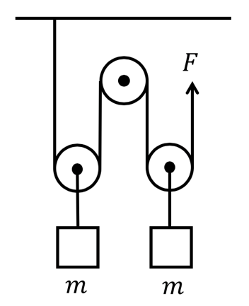Block A (mass $m_{A}=3 \text{kg}$) and B (mass $m_{B}=2 \text{kg}$) are tied to a massless rope hanging over through two pulleys. The blocks are moving due to the downward gravity force. Neglecting all frictions and the mass of the pulleys, please find the acceleration of block A (specify both its magnitude and direction, $g=9.8 \text{m/}{\text{s}}^{\text{2}}$).
2. Two blocks with the same mass $m$ are hanging on two pulleys (see the figure). The pulley in the middle is fixed on a wall, while the other two can move freely. A force $F$ (upward) is applied to the rope so that the system is stationary. All the ropes are in vertical direction (except when they are winding around the pulleys). Ignoring all frictions and the mass of the pulleys:
   1. If the end of the rope moves upward by a distance of $Δl$, how will the two blocks move?
   2. What is the magnitude of this force?

**Solution:**

1. Now that you are a grown-up adult in the University, we advise you to use energy arguments instead of the old free-body diagram to solve such “ideal” problems with no disgusting frictions.

Suppose that A drops a distance $h\left(t\right)$ starting from time $t=0$. Obviously

$$\frac{dh\left(t\right)}{dt}=v\left(t\right), \frac{d^{2}h\left(t\right)}{dt^{2}}=a\left(t\right)$$

are the speed and (magnitude of) the acceleration of the two blocks.

The system has constant total mechanical energy. Its value is

$$E\left(t\right)=\frac{1}{2}\left(m_{A}+m_{B}\right)v^{2}\left(t\right)+\left(m_{B}-m_{A}\right)gh\left(t\right)=\text{const}$$

Here we choose the initial configuration to have zero potential energy. Take the time derivative of the energy, we get

$$\frac{1}{2}\left(m_{A}+m_{B}\right)\frac{d}{dt}\left(v{\left(t\right)}^{2}\right)+\left(m_{B}-m_{A}\right)g\frac{dh\left(t\right)}{dt}=0$$

Or

$$\left(m_{A}+m_{B}\right)v\left(t\right)a\left(t\right)+\left(m_{B}-m_{A}\right)gv\left(t\right)=0$$

Crossing out the common factor $v\left(t\right)$, the magnitude of the acceleration is

$$a\left(t\right)=\frac{m_{A}-m_{B}}{m_{A}+m_{B}}g=\frac{\left(3-2\right)\text{ kg}}{\left(3+2\right) \text{kg}}×9.8 \text{m/}{\text{s}}^{\text{2}}=2.0 \text{m/}{\text{s}}^{\text{2}} \left(\text{2 significant digits}\right)$$

*Remark:*

* *This question is used to warn those students who will naively write that the acceleration is*

$$\frac{m_{A}-m_{B}}{m_{A}}g \left(\text{wrong}\right)$$

*Can you figure out why they think so?*

* *For students who insist using the free-body diagram, we ask you to solve a variant of this question: what if the rope has mass $m$ uniformly distributed on it?*
* *When physicists solve problems, they always try to find extremum (like what you have seen in the Principle of Least Action) or invariance (i.e. something which is conserved). You can try this when solving the assignment problems too: find conserved quantities as many as you can, then other things can be obtained through some kind of differentiation.*

1. 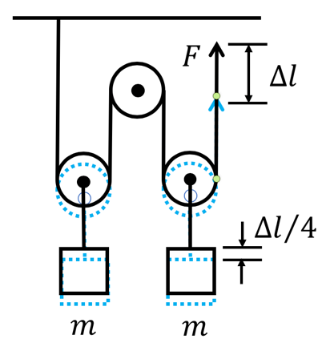
   1. The two blocks will move upward by ${Δl}/4$ (You can just feel it from the geometry – we don’t want to say too much here)
   2. We use the energy argument again. We use the force to pull up the two blocks very slowly, so we need not consider the kinetic energy. The work done by the force is converted to the increase in the system potential energy. Therefore

$$FΔl=2mg\frac{Δl}{4}⟹F=\frac{mg}{2}$$

**Problem 3 – Work**

*(This problem is adapted from the PHYS1110 Quiz 1 in 2015-16 Academic Year)*

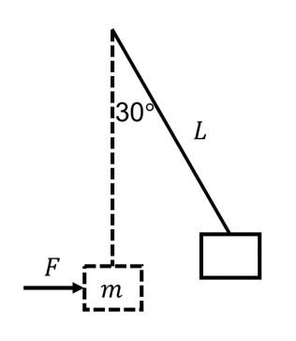A block with mass $m$ is suspended vertically on a non-stretching rope (i.e. its length will not change) of length $L$. Now, we apply a varying *horizontal* force on the block, and move it to a final position, in which the rope forms an angle of 30 $°$ to the vertical direction (see the figure). Neglecting the mass of the string, please:

1. Find the magnitude of the force required to maintain the block at the final position;
2. Calculate the work done on the block: (*Be careful about these two questions*)
   1. by the tension in the rope.
   2. by the horizontal force $F$;

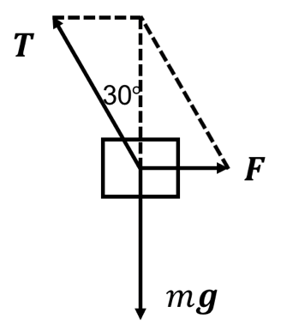

**Solution:**

1. From force diagram, we have
$$\left.\begin{aligned}\text{Horizontal}:&&F&=T\sin{30°} \\ \text{Vertical}:&&T\cos{30°}&=mg\end{aligned}\right\}⟹F=mg\tan{30°}=\frac{mg}{\sqrt{3}}$$

2. The work done by a force is given by
 $$W=\lim_{Δl_{n}→0}{\sum_{\text{path}}{Δl_{n}∙F_{n}}}=\int_{\text{path}}{dl∙F}$$

  1. During the whole process, $T$ is perpendicular to $dl$ all the time, so the tension does *zero work.*
   2. Method 1: The work done by $F$ is converted to the increase in the potential energy of the block. Therefore

$$W=Δ\left(\text{P.E.}\right)=mgL\left(1-\cos{30°}\right)=mgL\left(1-\frac{\sqrt{3}}{2}\right)$$

Method 2: Using the definition

$$W_{F}=\int_{0}^{\frac{π}{6}}{mg\tan{θ}∙L\cos{θ}dθ}=-mgL\left(\frac{\sqrt{3}}{2}-1\right)$$

*Question: Can you see why the component of $dl$ in the direction of $F$ is $L dθ\cos{θ}$?*

**Problem 4 – What is the Determinant? (Preparing to Learn the Cross Product)**

*You will need the result of this question in the Tutorial Session of Week 9.*

In 2D Cartesian coordinate system, we use two vectors not parallel to each other

$$a=\left(\begin{matrix}a_{x} \\ a_{y}\end{matrix}\right), b=\left(\begin{matrix}b_{x} \\ b_{y}\end{matrix}\right)$$

(see the figure) to construct a **parallelogram** ABCD

1. Find the distance between the point D and the line AB;
2. Please show that the area of the parallelogram ABCD is given by

$$A=\left|a_{x}b_{y}-a_{y}b_{x}\right|$$

This result *defines* the $2×2$ determinant:

$$A=\det\left(\begin{matrix}a_{x} & b_{x} \\ a_{y} & b_{y}\end{matrix}\right)=a_{x}b_{y}-a_{y}b_{x}$$

1. 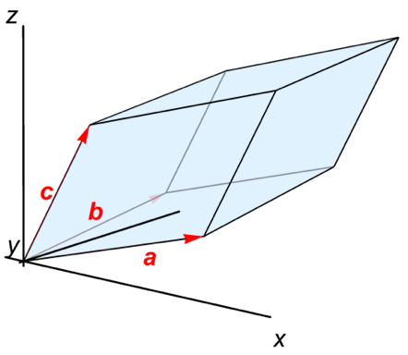*If you have spare time, you can construct a **parallelepiped** in 3D space by three 3D vectors

$$a=\left(\begin{matrix}a_{x} \\ a_{y} \\ a_{z}\end{matrix}\right), b=\left(\begin{matrix}b_{x} \\ b_{y} \\ b_{z}\end{matrix}\right), c=\left(\begin{matrix}c_{x} \\ c_{y} \\ c_{z}\end{matrix}\right)$$

(see the figure) and calculate its volume $V$. The answer *defines* the determinant of $3×3$ matrices:

$$V=\det\left(\begin{matrix}a_{x} & b_{x} & c_{x} \\ a_{y} & b_{y} & c_{y} \\ a_{z} & b_{z} & c_{z}\end{matrix}\right)$$

Please find the explicit expression of this determinant.

*Note:* After solving this problem, you may feel more comfortable when learning the **cross product** of two 3D vectors in Week 7.

**Solution:**

1. First, recall how the distance between a point and a line is defined. We draw from D a line *perpendicular* to AB and get a point of intersection E on line AB. The length of DE is the desired distance.

Let the coordinate of E be $\left(x_{E}, y_{E}\right)$. Since AE is parallel to AB, we must have

$$\vec{AE}=t \vec{AB} \text{or} \left(x_{E}, y_{E}\right)=t\left(a_{x}, a_{y}\right)$$

Besides, AE is perpendicular to DE. Thus

$$\vec{AE}∙\vec{DE}=x_{E}\left(x_{E}-b_{x}\right)+y_{E}\left(y_{E}-b_{y}\right)=0$$

Therefore

$$t=\frac{a_{x}b_{x}+a_{y}b_{y}}{a_{x}^{2}+a_{y}^{2}} ⟹ x_{E}=\frac{a_{x}b_{x}+a_{y}b_{y}}{a_{x}^{2}+a_{y}^{2}}a_{x}, y_{E}=\frac{a_{x}b_{x}+a_{y}b_{y}}{a_{x}^{2}+a_{y}^{2}}a_{y}$$

The distance DE is just

$$DE=\sqrt{{\left(x_{E}-b_{x}\right)}^{2}+{\left(y_{E}-b_{y}\right)}^{2}}=\frac{\left|a_{x}b_{y}-a_{y}b_{x}\right|}{\sqrt{a_{x}^{2}+a_{y}^{2}}}$$

1. There are many ways to do the problem. Of course, you can use the result in question 1) and get the answer quickly. However, for some other purposes, we introduce a different method which we call “cut and rearrange”, which you must have encountered in primary school.

We draw a line through point D parallel to the $x$ axis. Cut off the triangle DPC and move it to AQB. Now we obtain a new parallelogram AQPD, which has the same area as ABCD. However, since its base AQ is on the $x$ axis, the formula $A=ah$ can now be applied more easily. The height of AQPD is obviously equal to $b_{y}$. It remains to find the base AQ.

Since BQ is parallel to $b$, we use the usual trick and set

$$\vec{BQ}=αb$$

Then, from $\vec{OQ}=\vec{AB}+\vec{BQ}=a+αb$, we obtain (for the $x, y$ components respectively)

$$\left\{\begin{aligned}x_{Q}&=a_{x}+αb_{x} \\ 0&=a_{y}+αb_{y}\end{aligned}\right.⟹α=-\frac{a_{y}}{b_{y}}, x_{Q}=a_{x}-\frac{a_{y}b_{x}}{b_{y}}$$

The final answer is

$$A=\left|x_{Q}\right|\left|b_{y}\right|=|a_{x}b_{y}-a_{y}b_{x}|$$

1. The major difficulty comes from the fact that the base of the parallelepiped is not in the $xy$-plane, which makes the formula $V=Ah$ not easily applicable.

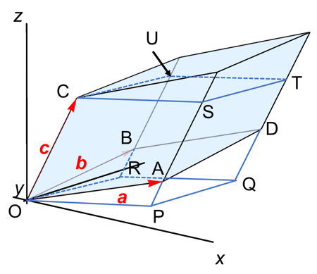Let CSTU be the cross-section through C of the parallelepiped parallel to the $xy$-plane. We observe that if we move the part above CSTU to the bottom of the parallelepiped, we will get a new parallelepiped OPQR-CSTU (notice that OPQR is *in the $xy$-plane*), which has the same volume as the original parallelepiped.

Let the coordinates of P and R be respectively

$$P:\left(x_{P}, y_{P}, 0\right), R:\left(x_{R}, y_{R}, 0\right)$$

The vectors $\vec{AP}$ and $\vec{BR}$ are parallel to $c$. Therefore, they can be expressed as

$$\vec{AP}=αc, \vec{BR}=βc$$

And the coordinates of P and Q can be found from

$$\vec{OP}=\vec{OA}+\vec{AP}=a+αc, \vec{OR}=\vec{OB}+\vec{BR}=b+βc$$

Therefore, we write

$$\left\{\begin{aligned}x_{P}&=a_{x}+αc_{x} \\ y_{P}&=a_{y}+αc_{y} \\ 0&=a_{z}+αc_{z}\end{aligned}\right., \left\{\begin{aligned}x_{R}&=b_{x}+βc_{x} \\ y_{R}&=b_{y}+βc_{y} \\ 0&=b_{z}+αc_{z}\end{aligned}\right.$$

We easily obtain

$$α=-\frac{a_{z}}{c_{z}}, β=-\frac{b_{z}}{c_{z}}$$

Therefore

$$\left\{\begin{aligned}x_{P}=a_{x}-\frac{a_{z}c_{x}}{c_{z}} \\ y_{P}=a_{y}-\frac{a_{z}c_{y}}{c_{z}}\end{aligned}\right., \left\{\begin{aligned}x_{R}=b_{x}-\frac{b_{z}c_{x}}{c_{z}} \\ y_{R}=b_{y}-\frac{b_{z}c_{y}}{c_{z}}\end{aligned}\right.$$

Using the results from question 2), we immediately get

$$\begin{aligned}A_{OPQR}&=\det\left(\begin{matrix}x_{P} & x_{R} \\ y_{P} & y_{R}\end{matrix}\right)=x_{P}y_{R}-x_{R}y_{P} \\ &=\frac{1}{c_{z}}\left(a_{x}b_{y}c_{z}+a_{y}b_{z}c_{x}+a_{z}b_{x}c_{y}-a_{z}b_{y}c_{x}-a_{y}b_{x}c_{z}-a_{x}b_{z}c_{y}\right)\end{aligned}$$

The height of the new parallelepiped is evidently equal to $c_{z}$. Then, the volume $V$ is simply

$$V=A_{OPQR}×c_{z}=a_{x}b_{y}c_{z}+a_{y}b_{z}c_{x}+a_{z}b_{x}c_{y}-a_{z}b_{y}c_{x}-a_{y}b_{x}c_{z}-a_{x}b_{z}c_{y}$$

This defines the determinant

$$V=\det\left(\begin{matrix}a_{x} & b_{x} & c_{x} \\ a_{y} & b_{y} & c_{y} \\ a_{z} & b_{z} & c_{z}\end{matrix}\right)$$

*Remark*:

* If we are really pedantic, we should say that the determinant is defined by the **signed area/volume** of the parallelogram/parallelepiped. Because if we exchange the name of the two vectors, the determinant will *change its sign*, which means that it may be *negative*. Therefore, in order to get a positive area/volume, the columns of the matrix should be ordered in a specific way (known as the **right-hand rule**, which you may have heard before). Have you noticed that this *signed* area/volume can be directly obtained by our “cut and rearrange” method?
* You can check by direct calculation that if we *exchange the columns and the rows* in the matrix, the determinant is not affected. This is a general property of determinant of any size. *A small challenge for you: can you see why this is true by* ***geometric*** *arguments? (I don’t know the answer now)*